Name: | ___________________________________________________ |  |  |  | Date: ___________
 | Year 9 Mathematics  Investigation 1, 2015  Topic – Index laws  Take home component
Date out: |  | Week ____ Date _____________ | Date Due: | Week ____ Date _____________
Take home component weighting: |  | 0% of the year | In-class component weighting: | _____% of the year.
AIM: In this assessment, you will be investigating index laws and their real life applications

1. | Write definitions for the following mathematical terms:
a) | Base
b) | Power
c) | Index
d) | Expanded form
e) | Index notation

2. | In Year 8, part of your learning included index laws. To help jog your memory about these laws, watch these videos below.
 | http://splash.abc.net.au/media/-/m/1245048/the-power-of-exponential-notation
 | This video provides a quick recap about what indices are and how to write numbers using index notation
 | http://splash.abc.net.au/media/-/m/1245070/laying-down-the-law-for-exponents
 | This video revises the first two index laws.
 | http://splash.abc.net.au/media/-/m/1519673/is-it-one-or-raised-to-the-power-zero-
 | This video revises the next two index laws.
 | Summarise the four index laws below, including examples.
 | Index Law 1: Multiplication | Index Law 2: Division
 | Index Law 3: Brackets | Index Law 4: Zero

3. | Use Index Law 1 to simplify the following:
a) | 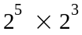 | b) | 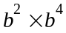
c) | 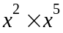 | d) | 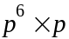
e) | 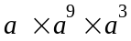 | f) | 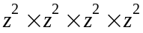

4. | Use Index Law 2 to simplify the following:
a) |  | b)
c) |  | d)
e) |  | f)

5. | Use Index Law 3 to simplify the following:
a) | 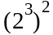 | b) | 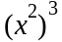
c) | 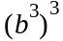 | d) | 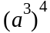
e) | 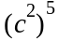 | f) | 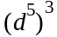

6. | Use Index Law 4 to simplify the following:
a) | 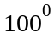 | b)
c) |  | d)
e) | 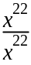 | f) | 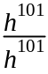

There are three other index laws that you need to know for Year 9 Maths. You will explore each of these laws and by the end of this investigation, you will be able to write general rules for them.

7. | Index Law 5:
 | Expand and then simplify to remove brackets. Express your answers in index form.
a) | 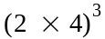 | b) | 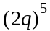
c) | 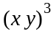 | d) | 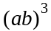
e) | 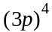 | f) | 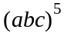
g) | How are the index numbers in the question related to the index number in the answer?
h) | Generalise your finding by completing the following:
 | 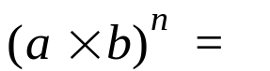 ___________

8. | Index Law 6:
 | Expand and then simplify to remove brackets. Express your answers in index form.
a) | 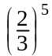 | b) | 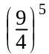
c) | 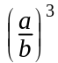 | d) | 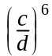
e) | 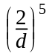 | f) | 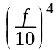
e) | How are the index numbers in the question related to the index number in the answer?
f) | Generalise your finding by completing the following:
 | 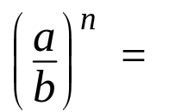 ___________

9. | Index Law 7:
a) | Simplify the following algebraic fraction, leaving your answers as fractions.
i) |  | ii)
iii) |  | iv)
v) |  | vi)
b) | Use Index Law 2 to simplify the same questions:
i) |  | ii)
iii) |  | iv)
v) |  | vi)
c) | Consider your answers for part a) and part b). How are the answers related?
d) | Generalise your finding by completing the following:
 | 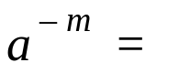__________

10. | Putting it all together.
 | Simplify the following algebraic expressions. Express answers with no brackets.
a) | 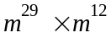 | b) | 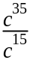
c) | 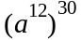 | d) | 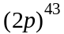
e) | 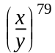 | f) | 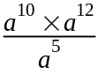
g) | 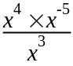 | h) | 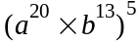
i) | 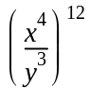 | j) | 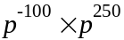
k) | 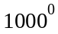 | l) | 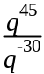
m) | 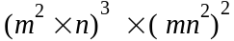 | n) | 